**Huddersfield Flower Club Newsletter**

September 2020

Hello Ladies

With September now upon us the days are a little shorter and a little colder and we keep being told that a heatwave is just around the corner.  How I hope that is true but as the weather report changes from one day to another I will not hold my breath and confirm the weather by opening the curtains!

Sadly still no indication of when we are allowed large group meetings to open up but we have been active in other ways:

The Allotment Federation show scheduled for August went ahead with photographic images of competitor entries.  Congratulations to:

Floral Art

D1 VE day 75th Anniversary an exhibit to depict this event

  1st Judith Norris    2nd Diane Hardcastle     3rd Teresa Kelly

D2 Grow your own an exhibit to include both flowers and vegetables.



Judith Norris

D1 VE Day



June Hirst

 D2 Grow your own

Anne Ridsdale and Sheila Drybrough had an outing:

“ Went to Harlow Carr gardens last week with Sheila, took a picnic and had a lovely few hours, it was nice and quiet too,  until we decided to have a coffee and had to queue!!”

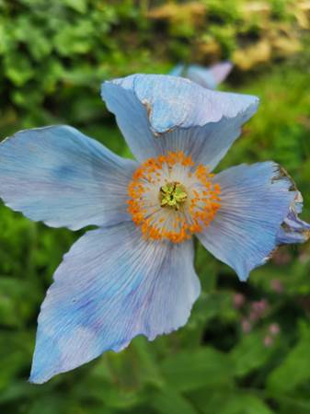

Diane Hardcastle has been a very busy bee:

“ Hi I’ve been busy working still part time at Morrisons with flowers.  Making some nice bouquets.  Also been sewing headbands and scrub bags for nurses and Newsome care home.    I then started face masks and lost count of the number made, along with ladies in Kirkheaton village we raised £1,150 for the charity  Yetton Together a Kirkheaton community centre charity.    Also been knitting for my grandson who will be arriving in 8 weeks and finally been helping my daughter with her candle and wax melt business.



I would also like to share a photo of my sisters “Squirrel proof bird feeder” Shortly after the photograph was taken the squirrel discovered that although it had got in to feast on the food  provided for birds it could not get out !    it was now on its side trying to bite through the bars, so bravely my sister donned her gardening gloves got the feeder down to give the distressed animal some purchase on the ground and it did find its feet to freedom.   I am happy to report that no squirrel or sisters were injured in this episode.

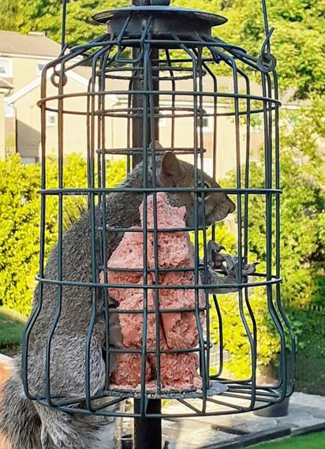

Other great news to share with you is that Diane Hardcastle welcomed her new grandson Harry into the world last week.  Congratulations to the new Nana.

Barbara Moorhouse will be a very young 90 years old this month on the 16th September and I am sure that you would want to wish a very Happy Birthday to long standing member Barbara.

Despite the restrictions on social activities we are still finding ways to enjoy our hobbies.  Please do look at both the Facebook pages of Huddersfield Flower Club and North East Area of NAFAS.  Technical demonstrations, competitions and garden visits are just some of the interesting features that you will see there.  Both are public pages so you do not need a Facebook account to open them.

Even though we cannot meet in person club administration is still going ahead. This month the Annual General Meeting scheduled to for the 16th September will go ahead at 10.30 am by video link.  If you wish to view the proceedings and you are familiar with the concept then I can send you a Zoom Meeting Link so that you can be with us virtually.

Please note however as I do not wish to disappoint you, my background is the spare room and I do not have a library of books behind me.   Minutes of the meeting will be transcribed and I will forward them on to you by email.

This month I have taken the drastic measure of withholding water from my green tomatoes.  According to the Chairman of the Allotment Federation this will shock them into ripening.  I will report back on this method.  There are so many other tips such as hanging the trusses upside down, ripening with apples or bananas or packing in a large cardboard box that it is obviously a bone of contention for many gardeners.   One of the other garden myths that was completely destroyed this morning is that slugs do not like crawling over rough surfaces.  No one told the slug that had ascended up my rough stone house wall and slithered to a first floor window.  Obviously it was in training to climb Mount Everest!!

Until the next time I hope that you all keep safe and well.  Please keep sending in your stories to share with others otherwise I might have to fill the page with the oracle of the Elland Feud which my husband has been working on.  It is formatted  over 91 pages so you really do not want that!

**Quiz**

**All Flowers, Trees or Herbs:**

1. Overworked girl

2. This flower is one in the eye for the girl

3. A wise old herb

4. A nice pad on the lake

5. Please remember me

6. Receptacle for dairy product

7. Sugary Prince

8. A vicious Welsh emblem

9. Cunning animal’s handwarmer

10.Duration

11.Wed precious metal

12.Not always at sea

13.Lonely when grown with onions

14.A religious man’s hat

15.Not so much a tree, sounds like an island

16.If you’re up one of these, you’re in lumber

17.Morecambe, San Francisco and Bengal have this tree in common

18.There are always two of these trees by the sound of it

19.Would you find this tree close to the ocean?

20.Someone crazy about bricks and mortar

**Answers in attached file above**

**SMILE CORNER**

1. Just ate a frozen apple. Hardcore.

2. Bought a litre of Tipp-Ex yesterday. Huge mistake.

3. I've started a business building yachts in my attic. Sails are going through the roof.

4. I stayed up all night to see where the sun went. Then it dawned on me.

5. I tried to catch some fog today but I mist.

6. I bought a dog from my local blacksmith. When I got it home it made a bolt for the door

Funny Stories from Members

Just had a video call with one of my granddaughters and a little voice said 'turn your camera on grandma' when we had technical difficulties. The granddaughter in question is two and a half years old!

Take care all Linda Hirst

Called at Sainsbury’s with my mask on asked an employee if she could tell where the bags of ice were, she said she would show me.  I did feel we were going in the wrong direction and this was confirmed when she showed me the bags of **R**ice I had to take my mask down and ask again. I bet that’s happened more than once !

Lesley Kaye

It is still unclear when we will be able to resume normal club activities so once again here is a link to a demonstration for you to watch and lose yourself in for a little time. Don’t forget to skip the adverts first.

<https://youtu.be/G7M7LoN0Hr8>

A reminder of the area website and Facebook sites for you to peruse [www.nearea.org.uk](http://www.nearea.org.uk)

https:// en-gb.facebook.com/nafas.northeast

<https://en-gb.facebook.com/pages/category/Community-Organization/Huddersfield-Flower-Club>

Best wishes

Joyce