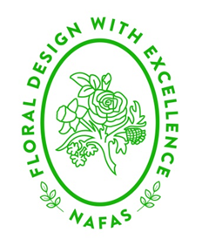 | NORTH EAST AREA OF NAFAS  THE GREAT ESCAPE  Workshop Details and Application Form

There will be 4 workshops held during our weekend, 2 on Saturday morning and 2 on Sunday morning.
- A floral based workshop with Mark Entwistle. There will be limited space and the same workshop will run on the Saturday and Sunday morning.
- A paper craft workshop with Sue Guilliatt making a selection of boxes, bags, cards, flowers etc. Again, places will be limited but the workshops will be different on Saturday and Sunday.
Across the 4 workshops there will be sufficient places for everyone to attend one of the workshops.
Below is an application form for you to indicate your preferences. Please rank your choices 1 to 4 with 1 being your first choice. Applications for the workshops will only be processed when you have paid in full for the event. Please rank your choices.
Saturday 13th August
Floral workshop …….
Papercraft workshop …….
Sunday 14th August
Floral workshop …….
Papercraft workshop …….
Name ………………………………………………………….
Please email your selection to Sue Guilliatt at s.d.guilliatt@gmail.com or post to 35 Southwold, Little Weighton, East Yorkshire, HU20 3UQ.

