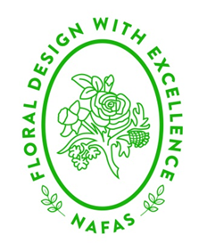 | NORTH EAST AREA OF NAFAS  THE GREAT ESCAPE 2022
APPLICATION FORM

Name ___________________________________________________
Address ___________________________________________________
___________________________________________________
Flower Club ___________________________________________________
Email ___________________________________________________
Telephone ___________________________________________________
Emergency Contact ___________________________________________________
(Name & contact number)

Any additional information (food allergies, anyone you would like to have accommodation near etc,)

I enclose payment of £50 / £350 being the deposit / full payment for the Great Escape 12th August – 14nd August 2022.
Name: ______________________________________________________
By making this payment I understand that all amounts are not refundable unless the event is cancelled or moved to a date I cannot attend.
Application forms can be completed electronically and emailed to s.d.guilliatt@gmail.com or posted to 35 Southwold, Little Weighton, East Yorkshire, HU20 3UQ.
Payment can be made by bank transfer or cheque made payable to North East Area of NAFAS and posted to the above address.
Barclays Bank
North East Area of NAFAS
20-45-14
60666580
…………………………………………………………………………………………………..

I enclose payment of £300 being the balance for the Great Escape 12th August – 14th August 2022 due by 30 June 2022.
Name: ----------------------------------------------------------------------------------------------
By making this payment I understand that all amounts are not refundable unless the event is cancelled or moved to a date I cannot attend.
Application forms can be completed electronically and emailed to s.d.guilliatt@gmail.com or posted to 35 Southwold, Little Weighton, East Yorkshire, HU20 3UQ.
Payment can be made by bank transfer or cheque made payable to North East Area of NAFAS and posted to the above address.
Barclays Bank
North East Area of NAFAS
20-45-14
60666580
…………………………………………………………………………………………………..

