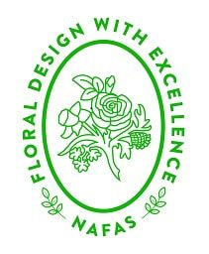
NORTH EAST AREA EDUCATION GROUP
MEMBERSHIP FORM 2024
The membership of the group is for two workshops with innovative tutors. Any member of a North East Area flower club can apply to be a member subject to availability of a space.
The programme for next year is:
Saturday 16th March 2024 – Dawn Weaver
Saturday 21st September 2024 – Lucy Richardson
Both will be at the Folk Hall, New Earswick Y032 4AQ
For 2024 the membership fee is £45.00, this is non-refundable but substitutes are allowed. Please complete the form below, along with your payment and return to Sue at s.d.guilliatt@gmail.com or post to 35 Southwold, Little Weighton, East Yorkshire, HU20 3UQ.
Best wishes
Dawn and Christine
Please print clearly or email your:
NAME:
ADDRESS:

EMAIL ADDRESS:
TEL:
cheques made payable to the North East Area of NAFAS,

or

by bank transfer
Account name - North East Area of NAFAS (Business Account)
Sort code 20-45-14
Account no 60666580

Please use “Education” as the reference

