NORTH EAST AREA OF NAFAS  President: Mrs Janet Ratcliffe |  | 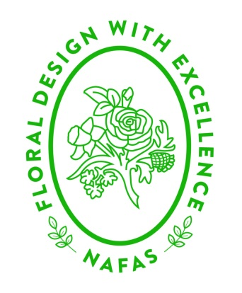
Treasurer | Chairman |  | Secretary
Mrs Sue Guilliatt | Mrs Sheila Drybrough |  | Mrs Ann Simpson
35 Southwold | 99 Kingsley Drive |  | 65 Hawthorn Terrace
Little Weighton | Birkenshaw |  | New Earswick
East Yorkshire | Bradford |  | York
HU20 3UQ | BD11 2NE |  | YO32 4AW
Tel: 01482 875621 | Tel: 01274 879633 |  | Tel: 01904 761619
s.d.guilliatt@gmail.com | sheiladrybrough@hotmail.co.uk |  | a.simpson25@btinternet.com

Chairman’s Winter Newsletter 2024
Dear Members and friends
I hope you have all had a good Christmas and I would like wish you all a Happy, Prosperous and a Peaceful New Year. We have definitely had some unusual weather for this time of year. I am sure like me you are all looking forward to some drier days when we can get out and about and enjoy either visiting gardens, gardening or going for walks where we can enjoy the country side.
Looking back on the past year I have had a wonderful time meeting members of various clubs, planning with the Executive Committee the events that will be coming up in this coming year. I hope that your clubs continue to enjoy the pleasure of flowers and hopefully grow a few more members along the way.
Our first Council meeting of the year on the 13 January 2024 will be held via Zoom commencing at 1pm. An invitation to attend the meeting will be sent a few days beforehand via an email from Ann Simpson.
The further three Council meetings of 2024 will be held at the Folk Hall, New Earswick York. Commencing at 1pm as follows:
- 20 April
- 20 July
- 16 November
The two Education Workshops will be held at the Folk Hall, New Earswick, York. The first is on the 16 March and the following one on the 21 September. If anyone wants to join this group, please contact Dawn Meakin who will be able to give you more information dawnsfloralheart@btinterent.com.
The Harrogate Spring Flower Show will be held between the 25th and 28th April 2024. The title of the NAFAS large scale exhibits is STYLE and SERVICE. The North East, Flowers North West and Northumberland and Durham have been invited to display their exhibits. Please note that for anyone considering entering the competitive classes the schedule will only be available online on the show website www.flowershow.org.uk The last day to enter is the 15th March and there are some interesting classes to enter. They have also included the imposed class which was held for the first time last year and proved a great success.
Further dates for your diary:
- 8th June Demonstration by Francine Thomas at the Rowntree Theatre. Ticket available from the 1st April via the booking office at the Rowntree theatre.
- 10 and 11th June Workshops with Francine Thomas at the Folk Hall, New Earswick, York.
- 9 - 12 July the Great Yorkshire Show is being held
- 26th -28th July Presidents Weekend in Glasgow “Highland Fling”.

The Harrogate Autumn Flower Show will be held at Newby Hall on the 13-15 of September.
This year there will be 3 competition classes, the third being a class that a novice can enter. (A novice is anyone who has not won a first prize at the Spring, Autumn or any NAFAS Show)
Finally, the Area AGM will be held on the 16th November after the council meeting which will be held in the morning.
Members of the Executive Committee and I look forward to seeing you at some of these events and hope that we have lots of pleasure in sharing the love of flowers and meeting up with friends, old and new, sharing in each other’s company.
Best wishes
Sheila

Affiliated to Charity Registration No. 1101348

