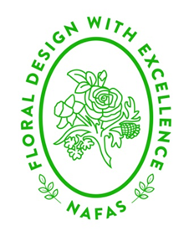

nORTH EAST

AREA NEWS

Edition 31

April 2021

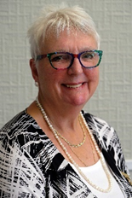

Dear Flower Club members,

I and many of my predecessors have begun this letter with comments on the season, gardens, flowers, and plants, and who am I to change this! As I write my letter in mid-March, we have recently had a very dry spell, which has enabled the snowdrops and crocuses to provide us with spectacular displays, whilst fortunately not getting buried under snow. I even had my first Camelia flower open at the end of January, which I am sure was earlier than last year. I hope that you are enjoying your own and others gardens as more spring flowers begin to appear.

Just to recap, as an Area we ran flower arranging and photographic competitions from April to December 2020, I am really pleased to say we had over 220 entries with 25 clubs taking part and a huge thank you to all those who entered. Photos of all the entries are on the Area website.

Following on from this the Area has taken part in the Chairman’s Challenge, a fun competition without rules and regulations other than photos must NOT be published on club websites or social media platforms until judging takes place at the end of each month.

The National Virtual Show is in April with demonstrations, talks and ‘how-to’ events. It will be a very exciting month and I am sure will fill a huge gap for us, as we aren’t yet able to attend our own flower clubs. There is more information elsewhere in this Newsletter plus the details are on the Area and National websites of these YouTube events.

Do not forget we have a ‘Scarborough Escape’ planned for 20 – 22 August. These weekends are always so enjoyable and lots of fun and again details are on the Area website.

Talking of the Area website we are in the very capable hands of Peter Mathers, the Area Webmaster, who is currently designing a new website for us with help from our new Media Officer and Deputy Sarah Spencer & Lynn Naylor including support from Vanessa Wellock our 2nd Vice Chairman. Peter will be able to tell us more about it at our next Council meeting on April 17th.

As the uncertainty continues of when and where we will be able to meet as flower clubs, the Area website contains details of both Area and National Demonstrators, Speakers, Judges and Teachers who are willing to do online activities/events. Remember there will not be any travel costs so this could enable you to have someone you may not have been able to consider previously.

The world of Zoom has opened our eyes to new ways of working and communicating and although we were and perhaps some still are hesitant of using this medium, NAFAS and its members nationwide would not have been able to continue to engage us in this wonderful world of flowers without it.

It reminds me of when my sister and I were children our parents would say to us ‘you will end up with square eyes’ if they thought we were watching too much television, well with Zoom we are certainly seeing those on screen in multiple small squares/rectangles, whilst we just sit at home!!!!

What would our parents think if they were to see what we are up to now?

Finally, I just wonder whether I will ever be able to get up at 6am again to get to meetings in Wetherby, York or London!

Take care everyone, keep safe, have your vaccinations and we hope to see you in the coming months at different events on the small screen, as we share our love for this beautiful world of flowers and foliage.

Janet Ratcliffe

N E Area Chairman.

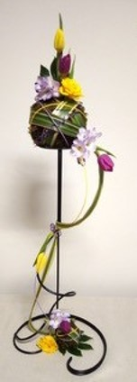Introducing zoom

Since August we have been having monthly workshops on Zoom.  This takes the form of two of our members demonstrating/ giving ideas on a theme, for example last month it was using spheres in flower arranging. The workshops are open to friends and relatives as well as members, to introduce other people to flower arranging and hopefully generate interest in joining the club in the future.

 Last month we also had a Zoom demonstration by one of our former members who is a demonstrator.  This was enjoyed by many of our members.

 We send out a monthly newsletter on email with information about the workshops.  Photographs are included of some of the workshop arrangements from the previous month.  Members are updated with news from the Area and from NAFAS and they are encouraged to look at websites.

 A system has been introduced where members of the committee have a list of members to contact by phone, together with a list of members who are not on email so they can be provided with a hard copy of the newsletter. The phone calls have been very productive, they keep all our members in touch.

Denise Smith

Secretary, Barwick-in-Elmet Design by Helen Lappage

SCARBOROUGH ESCAPE

We are pleased to announce a weekend in Scarborough on Friday 20th – Sunday 22nd August 2021. As you will appreciate these plans could be changed due to events outside our control but hopefully August is far enough in the future that we can look forward to this. We hope that you will be able to join us for what we plan to be a fun filled weekend.

***Where***

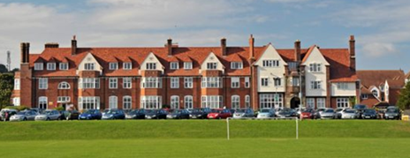The event will be held at Scarborough TEC, Filey Road, Scarborough, YO11 3AZ

***What***

Accommodation is in single en-suite shower rooms. Accessibility rooms are available.

***Workshops***

Same workshops will be held on Saturday and Sunday morning and there are limited spaces.

**Floral based workshop** with Vanessa Wellock.

**Paper craft workshop** with SueGuilliatt making a selection of boxes, bags, cards, flowers etc.

Applications for places on the workshops will be accepted when full payment for the event has been received.

***Cost***

The cost of the weekend will be £300 per person (non-refundable).

Places can be reserved by paying a £50 deposit. The full amount is due by 30 June 2021.

Application forms available to download from Area website or any problems contact Area Secretary, Ann Simpson, [annsimpson25@btinternet.co](mailto:annsimpson25@btinternet.co)

Online AREA EVENTS FOR APRIL & MAY 2021

We will be continuing our Area competitions to link into the National Chairman’s challenge in May. There is no challenge in April due to the National Virtual Show.

**May** – ‘A May day Celebration’ closing date 24 May

Entries can be floral designs or a collection of items or plants to interpret the title. The Area winner will be forwarded to NAFAS to become our entry in the Chairman’s Challenge.

Two photographs, one full and one close up, should be sent via email to Sue Guillliatt [s.d.guilliatt@gmail.com](mailto:s.d.guilliatt@gmail.com) The photograph **MUST NOT** be put onto social media or club websites until after the judging of the National competition.

The National winners are usually announced approximately 7 days after the closing date. Results will be posted on the National & Area websites and Facebook pages.

**ZOOM EVENTS:**

**April 20** – a Talk by Tony Cleaver ‘A Taste of Summer’ gardens not cookery! subtitle Backyards, back gardens & posh gardens.

**MAY 18** – workshop with Vanessa Wellock. Members can either work along with Vanessa or watch and prepare their design later.

To book both events please fill in the booking form on the Area website or email Ann Simpson at [a.simpson25@btinternet.com](mailto:a.simpson25@btinternet.com)

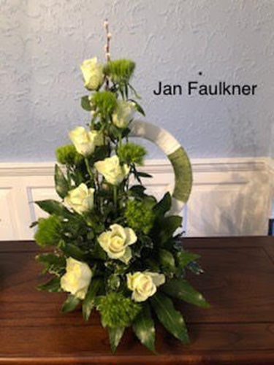 zoom workshops

I was delighted to be asked to tutor two workshops for the North East Area of NAFAS.

Some, including myself, had never heard of Zoom. Now it’s part of my life. I love a new challenge. I took on Zoom last September. I now hold five weekly ‘A Class Community’ learning classes for 60 learners. It was wonderful to share my new passion with flower club members. Let’s wake up the club members. So, on the 16th and 23rd February, twenty plus members came onto Zoom to do a step-by-step workshop. Each had received a list and knew what to gather together. I chose the theme ‘Rings and Things’ – 3 different looks on a design for Beginners, Intermediates and Advanced. It is wonderful to see so many smiley, happy faces. Zoom was managed beautifully by our Area Treasurer, Sue Guilliatt. Once members joined, we had a brief chat and catch up. I was introduced by Area Chairman Janet Ratcliffe.

Everyone was put on mute,I was put on spotligt (or speaker) and off we went step by step. Everyone was unmuted to check mechanics and then returned to mute and on we went.

Once completed, it was lovely to go back onto Gallery and see everyone’s designs. One by One members unmuted and I was able to comment on their designs. I was thanked by Tony Clever on the 16th and Janet Ratcliffe on the 23rd. I have four Area members joining me on my weekly Zoom classes.

I would recommend to any club, give Zoom a go. Have a Zoom coffee morning or afternoon tea and get members used to Zoom.

Book some demonstrations, it ight still be a while until we can meet face to face.

Let’s embrace Zoom and you too will enjoy the challenge. Every day is a learning day.

Jan Faulkner

Stokesly Flower Club

MARY DELANEY

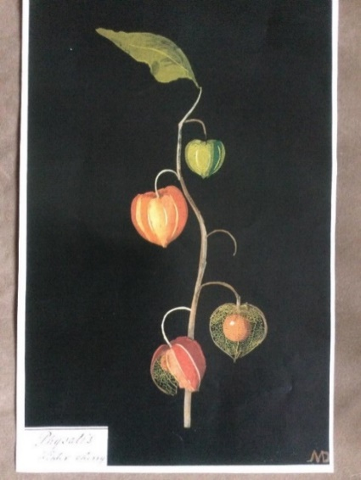Mary Delaney was born Mary Granville in 1700 and between 1774 and 1784 this remarkable lady produced 10 volumes of amazing paper flowers. She was already in her early seventies when she began this unusual hobby, which she called ‘Flora Delanica’ and just like Gertrude Jekyll it was due to her failing eyesight that eventually she was forced to give up her work.

After her husband died, she moved to London and spent time with the Duchess of Portland. She also became acquainted with George III, who was very impressed by her flowers and called them ‘paper mosaics’ Mary Delaney was also a friend of Joseph Banks who sailed with Captain Cook on his first voyage.

Her hobby had begun when one day she noticed that some red tissue paper was exactly the same colour as a nearby geranium. She cut the paper into the shape of the flower and then found some green paper for the leaves. This was the first of almost 1000 paper

collages she completed. Botanists of the time were much taken by these flowers of paper and Sir Joseph Banks said of them ‘they are the only imitations of nature I have seen from which I would venture to describe botanically without the least fear of committing an error’. Erasmus Darwin, who was a botanist and grandfather of Charles Darwin, wrote books on flowers and included his praise in a poem:

Of her hobby she wrote ‘I have invented a new way of imitating flowers’. She built them up sculpturally, layering the pieces of tissue paper to give contour and depth and then sticking them to solid black backgrounds.

The results were elegant, intricate and as Sir Joseph Banks had said, botanically accurate.

In 1897 these collages were bequeathed to the British Museum where they could be cared for properly. Many of you will remember Mary Patterson, former NE Area Chairman and National Demonstrator. A number of years ago we planned a visit to London and Mary contacted the Museum in advance and arranged for several volumes to be laid out for us to look at. What an experience, they are truly amazing and it is so hard to believe that they are made of paper. If ever you have the opportunity to visit it is indeed very worthwhile.

Janet Hayton, Area Judging Representative

NORTH EAST AREA OF NAFAS 2021-2022 EVENTS

|  |  |
| --- | --- |
| **2021** | **Event** |
| 17 **April** | Council Meeting to be held on Zoom |
| 7 **May** | National Flower Arranging Day |
| 13-15 | Great Yorkshire Show |
| 20-23 | Harrogate Flower Show (revised date) |
| 24 **July** | Council Meeting at The Folk Hall New Earswick (if restrictions allow) |
| 20-22 **August** | Scarborough Escape |
| 17-19 **September** | Harrogate Autumn Show at Newby Hall |
| 16 **October** | Council Meeting to be held on Zoom |
| **20 November** | AGM at Queen Elizabeth Grammar, Wakefield |
| **2022** |  |
| 4 **May** | Area Lunch at the Parsonage Hotel, Escrick, York |





Note from the editor

My thanks to all those who have contributed articles to this edition of the Area News. I am sure everyone will enjoy the interesting articles that are in this edition.

It was decided, because of the pandemic to put the Area News online. Flower Club Committees please provide hard copies to members who are unable to access the internet. Thank you.

The next edition will be available, online, in October. Please send articles about events your clubs have organised or other matters relating to flower arranging to me, together with a photograph via my email – [joyceharrow@yahoo.co.uk](mailto:joyceharrow@yahoo.co.uk) by the end of September.

Thank you to all those who have supported this issue.

Stay safe

Joyce