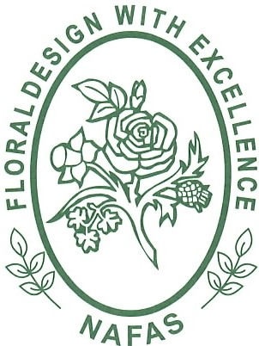

NORTH EAST AREA OF NAFAS

FLORAL ART CLASSES & REGULATIONS

Harrogate Autumn Flower Show

13 -15 September 2024

Newby Hall & Gardens,
Ripon HG4 5AE

Class categories

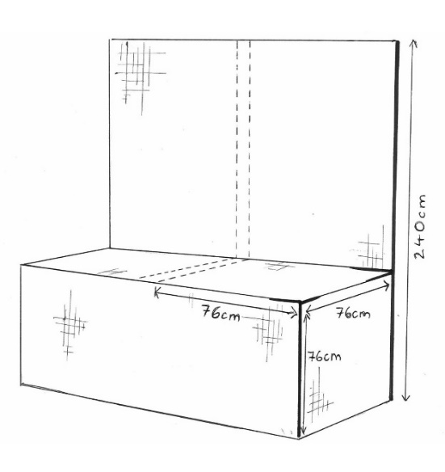
CLASS A – ‘FORAGED DELIGHTS’

An exhibit staged on a show bench raised 76cm from the ground. Space allowed 76cm wide x 76cm deep x 98cm height. Backboard will be black fabric rather than solid, therefore objects cannot be attached to it. Staging will be painted black.
To be viewed and judged from the front.

1st Prize £35, 2nd Prize £30, 3rd Prize £25

CLASS B – ‘AUTUMN GLORY’
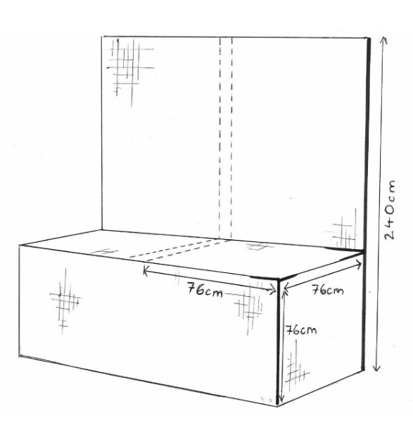
An exhibit staged on a show bench raised 76cm from the ground. Space allowed 76cm wide x 76cm deep x 98cm height. Backboard will be black fabric rather than solid, therefore objects cannot be attached to it. Staging will be painted black.

To be viewed and judged from the front.
Novice class – only open to members who have not won a first prize at the Harrogate Spring Show, Autumn Show or any NAFAS show.

1st Prize £35, 2nd Prize £30, 3rd Prize £25

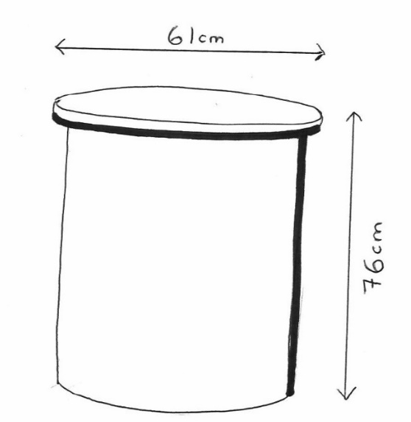
CLASS C – ‘SPIRAL SPHERES’
An exhibit, staging - a drum measuring 61cm wide. Height optional. Drum top stands 76 cm high from the ground, painted black. Plant material not to exceed the circumference of the drum. To be viewed and judged all round
1st Prize - £35, 2nd Prize £30, 3rd Prize £25

Class Information:
All entries will be included in both the show-wide President’s Choice and Harrogate Flower Show’s Best in Show award.
All competitors must be a member of a Flower Club which is affiliated to NAFAS.

An exhibit is composed of natural material in all its forms with or without accessories, contained within the space specified in the show schedule.
Pre-prepared background work in all classes is allowed with designs being completed in situ unless otherwise stated in the schedule.

Novices may enter any class but the NOVICE CLASS is open only to competitors who have never won a First Prize in Floral Art classes at any Harrogate Spring/Autumn or NAFAS show

Artificial plant material is not permitted and aerosols may not be used within the marquee.

All classes will be judged in accordance to the NAFAS Competitions Manual 4th edition (2023). The judges’ decision is final.

Staging Day:

Thursday 12 September to commence at 9am and must be completed by 6pm.

All classes are to be staged by only one competitor. Each competitor is allowed to enter no more than one entry in each class.

Judging will take place on Friday 13 September from 7am

Entries must not be removed before the close of the show on Sunday 15 September.

Entry forms are to be returned, along with the signed Risk Assessment form by Sunday 18 August 2024 to:

Mrs. Ann Simpson,
Area Secretary North East Area of NAFAS,
65 Hawthorn Terrace,
New Earswick,
York YO32 4AW

Email: nafas.northeast@gmail.com

